1. Click on Chrome Menu > More Tools > Extensions.

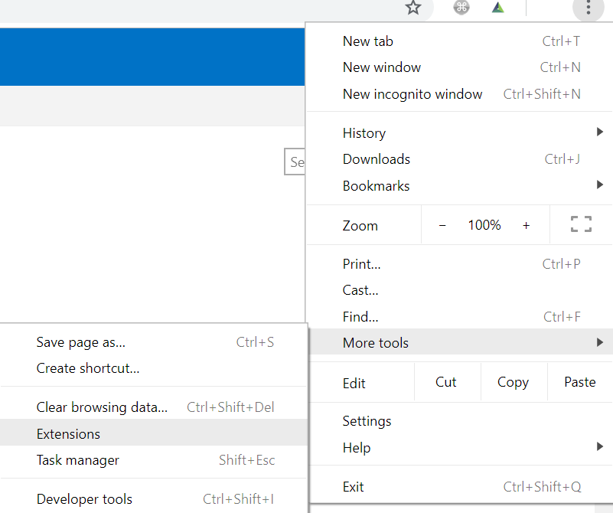

1. Toggle Developer mode.



1. You will now see below options.

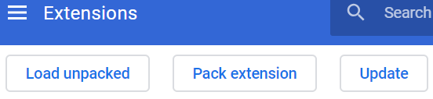

1. Click “Load unpacked” and select the folder that you downloaded to. Click Ok and the Extension is installed.

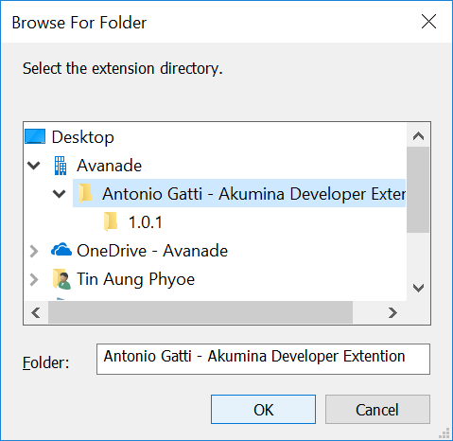

1. Whenever there is update click on “Refresh” icon in Extensions page.

